**Flume**

**Student Name: Nabh Sanjay Mehta Student Id: NSM190002**

**Date: 02/11/2020**

Part-1: Setup: In this section we will setup the directories and permission needed to complete this exercise.

Step-1: Start the Cloudera VM and then launch the “terminal” application

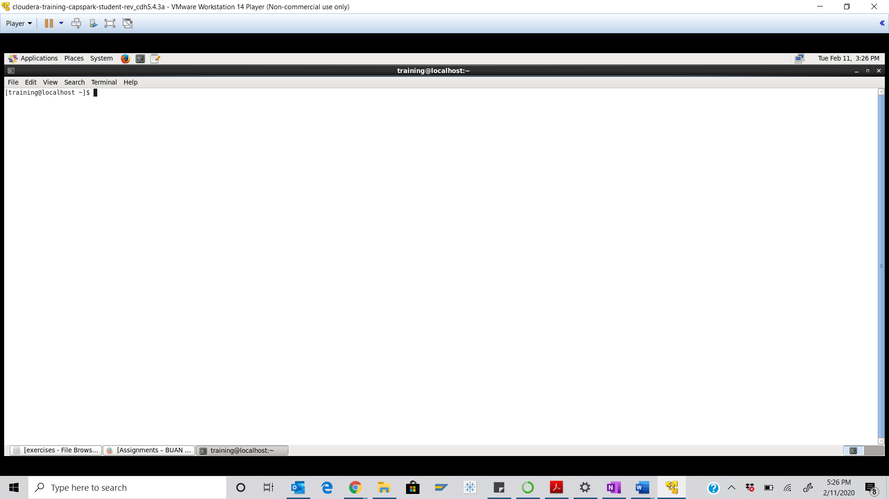

Step-2: Execute the following command at the shell prompt:

Q. Execute the following command at the shell prompt and take a screenshot of the shell output and paste it below.



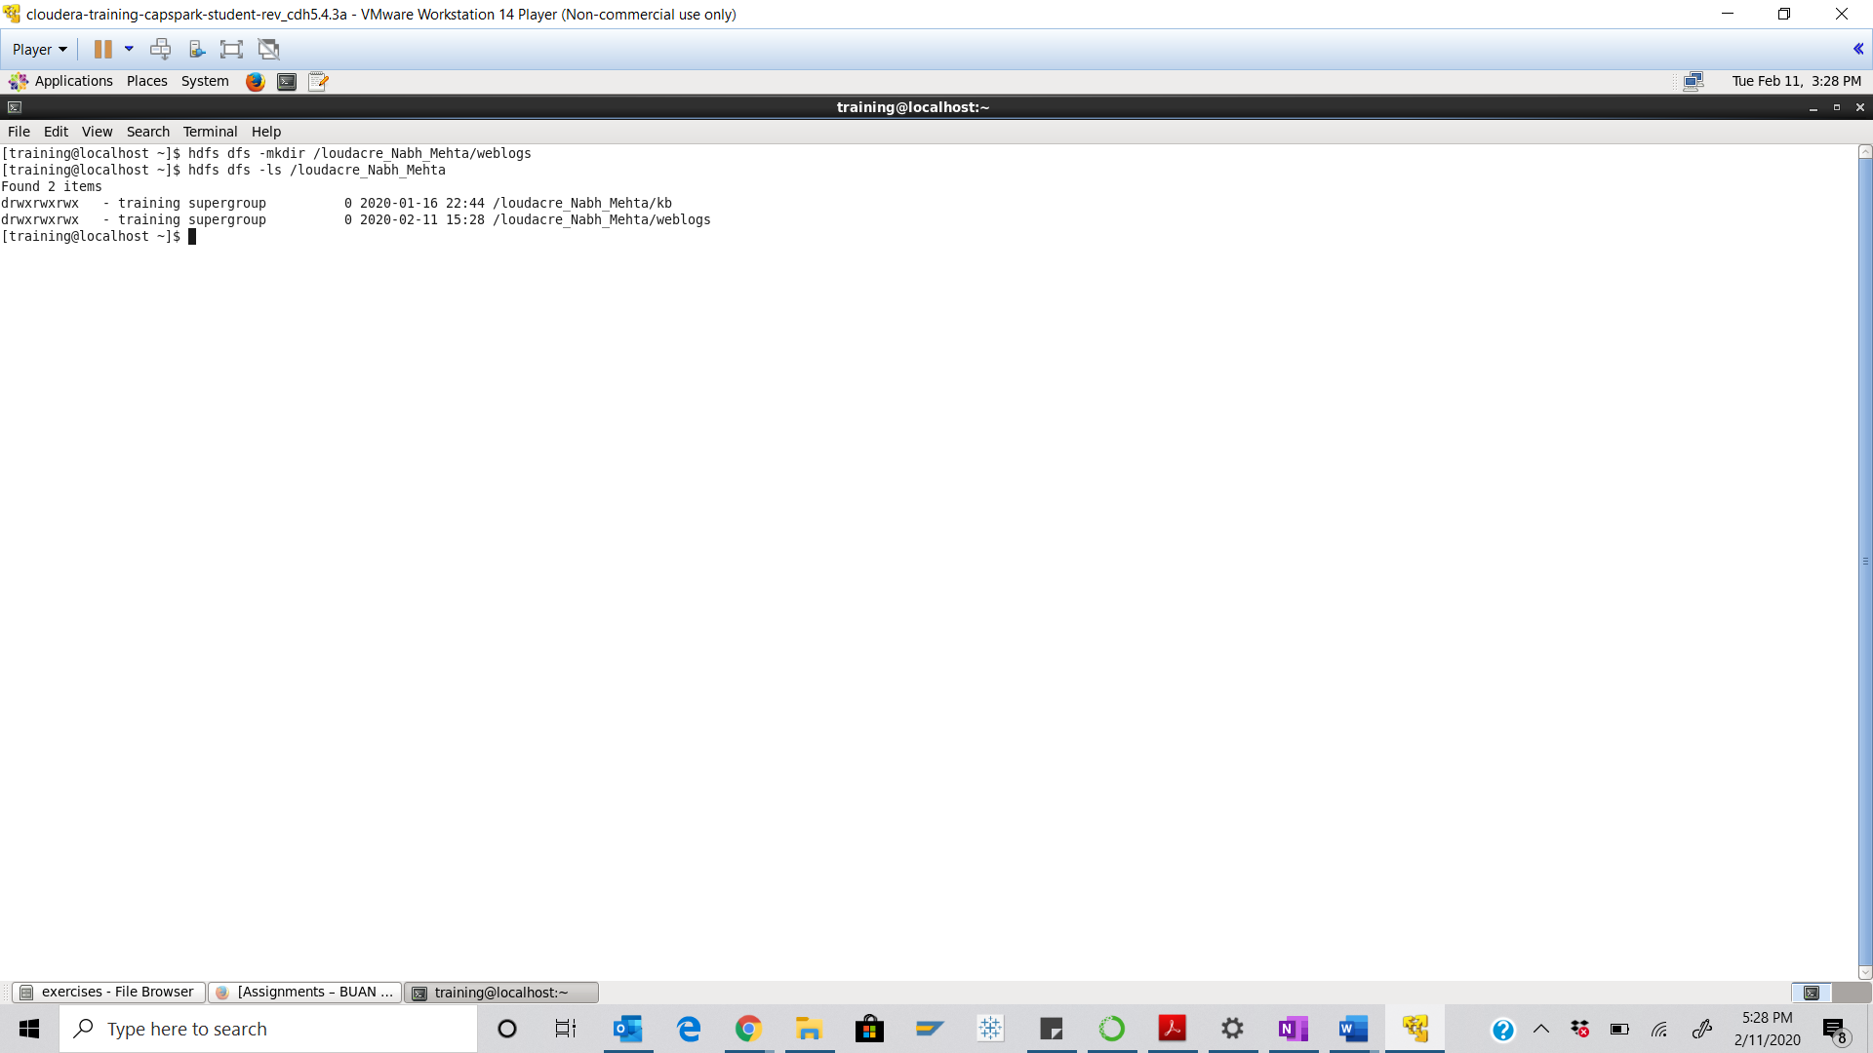

Step-3: Execute the following command at the shell prompt:

Q. Execute the following command at the shell prompt and take a screenshot of the shell output and paste it below.

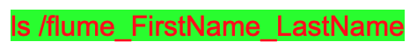

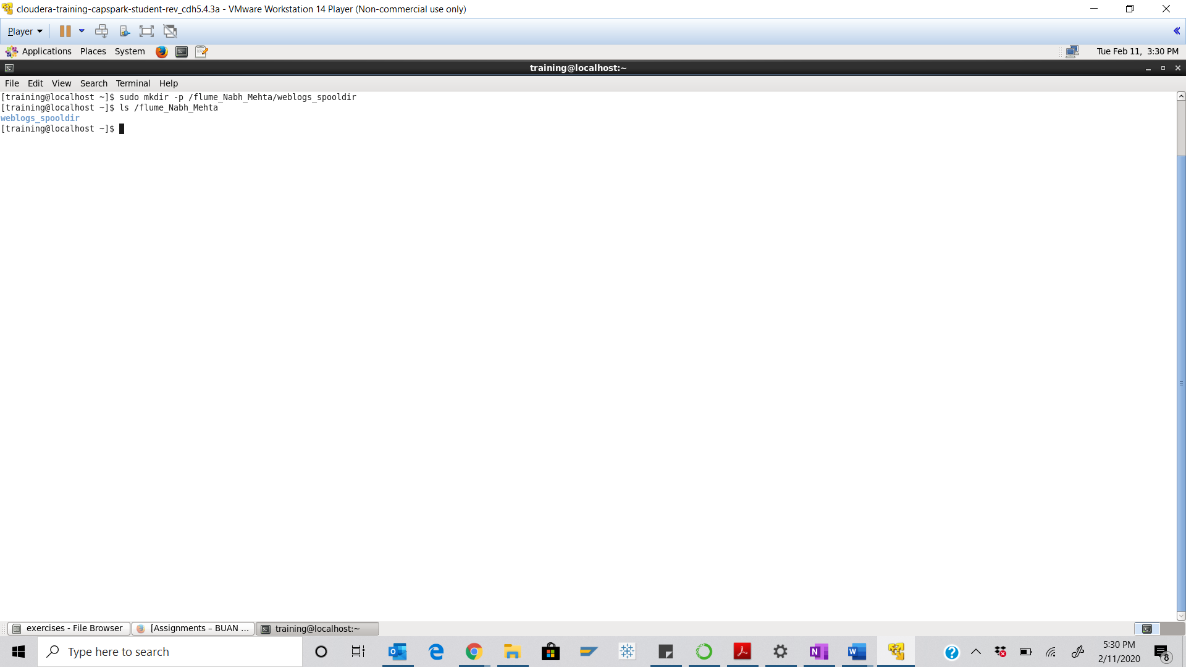

Step-4: Execute the following command at the shell prompt:

Q. Execute the following command at the shell prompt and take a screenshot of the shell output, highlight the flume_FirstName_LastName file and paste it below



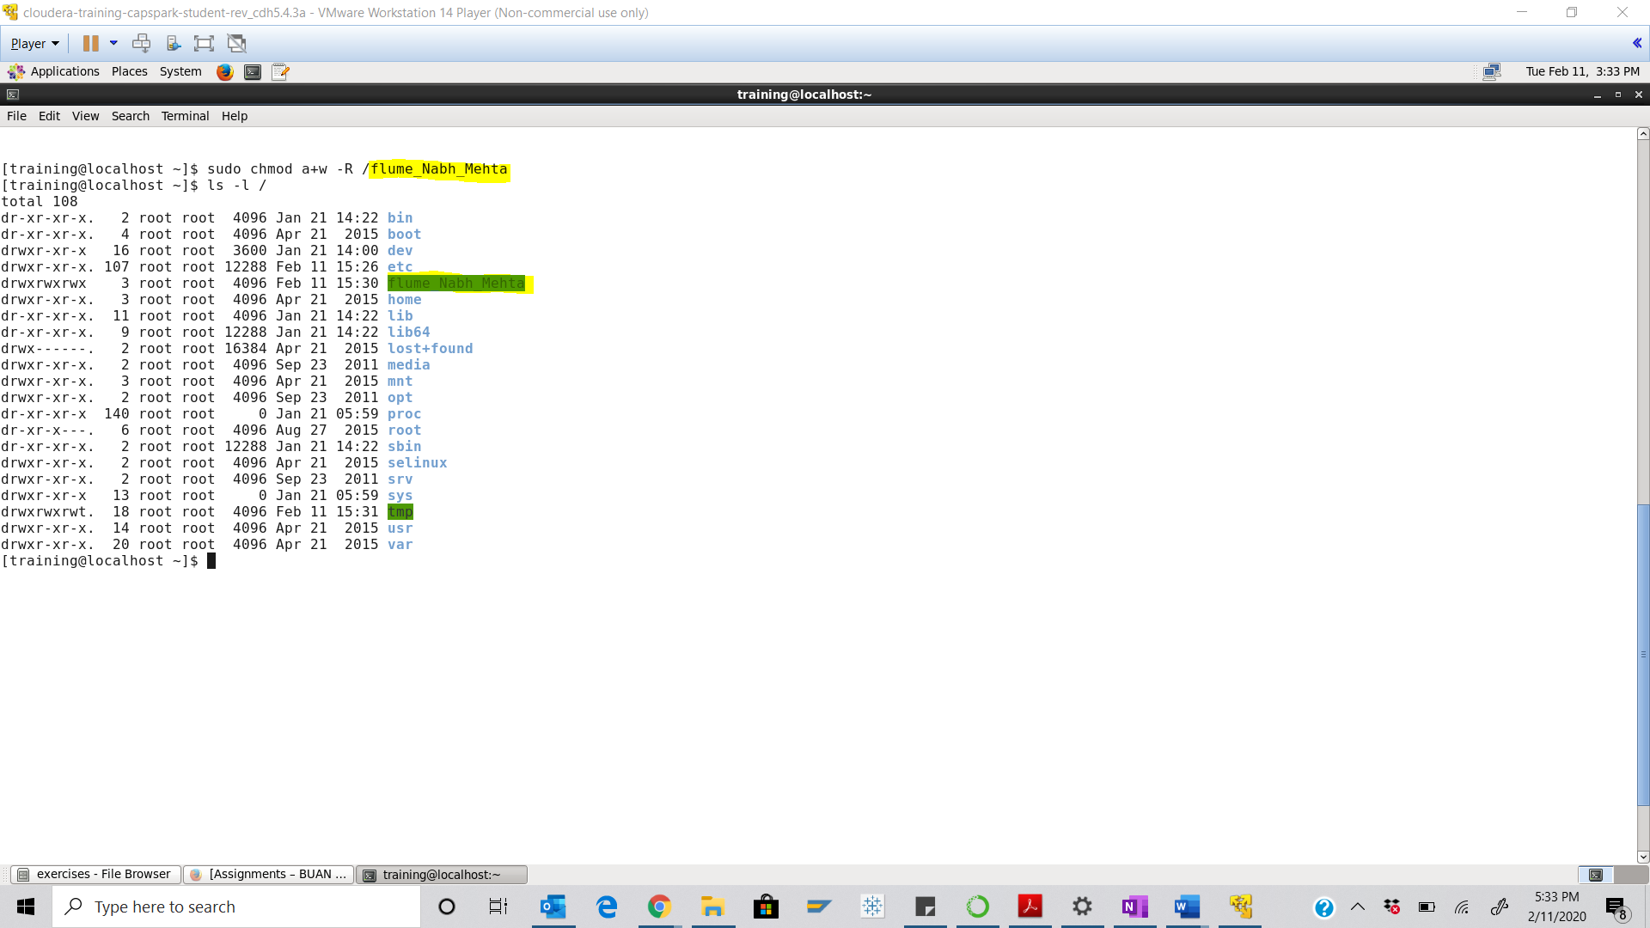

Part-2: Configuring the Flume Agent: In this section we will create the configuration file for the flume agent.

Step-5: Execute the following command at the shell prompt:



Q. Now type the command and execute. Take a screenshot of the shell output and paste it below.

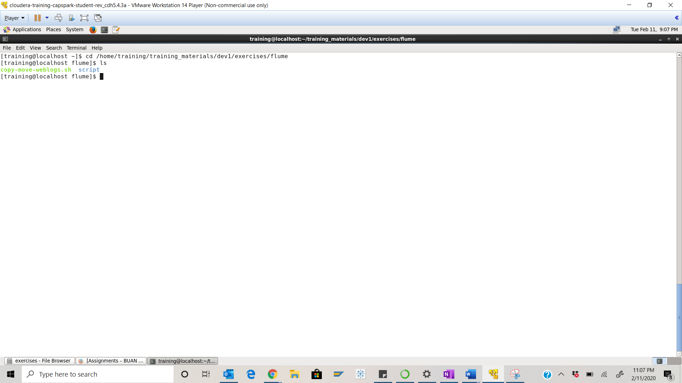

Step-6: Execute the following command at the shell prompt:

Enter the following command to enter Insert Mode:



Enter the following text in to the VI editor:

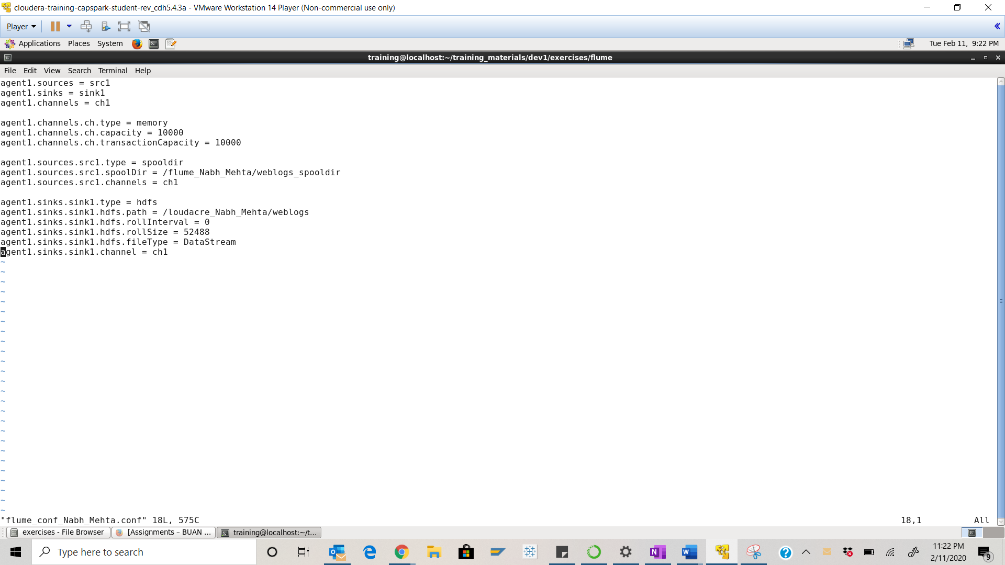

Part-3: Running Flume: In this section we will cover how to start the flume agent.

Step-7: Execute the following command at the shell prompt:

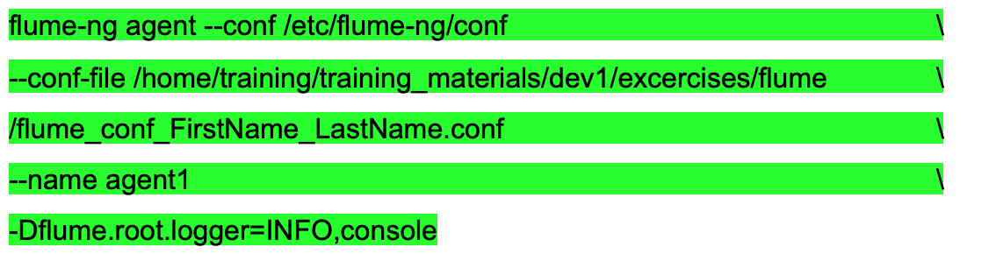

Q. Take a screenshot of the shell output and paste it below. The flume agent has now started. Why isn’t Flume ingesting any files?

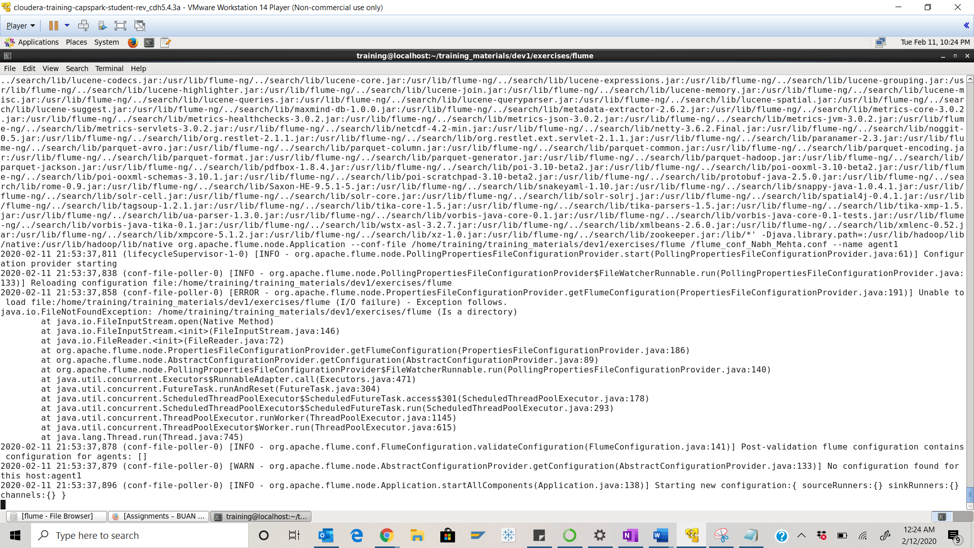

There is no file to ingest which is why it is not doing so.

Part-4: Simulating Web Log Files: This section will cover how to simulate the weblog files that Flume will ingest from the source (spooldir) to the sink (HDFS).

Step-8: Open a separate terminal window by clicking on “File” then “Open tab” as shown in the screenshot below. Once you have the second terminal tab open, setup the two terminal windows as shown in the second screenshot below.

Q. Take a screenshot of the two terminal windows after you have set them up as described.

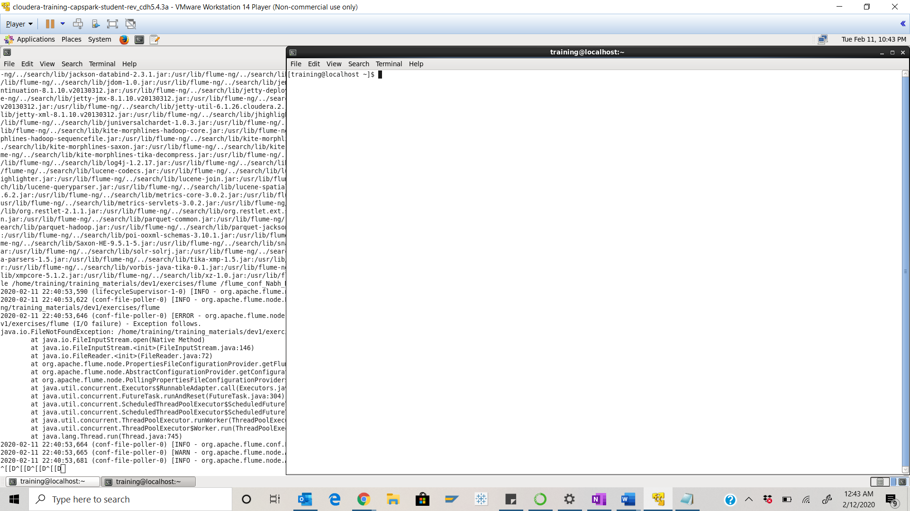

Step-9: Execute the following command at the shell prompt:

Q. The terminal that is running the flume agent should be displaying the log files that are being ingested. Take a screenshot of these log files while the flume agent is running and paste it below.

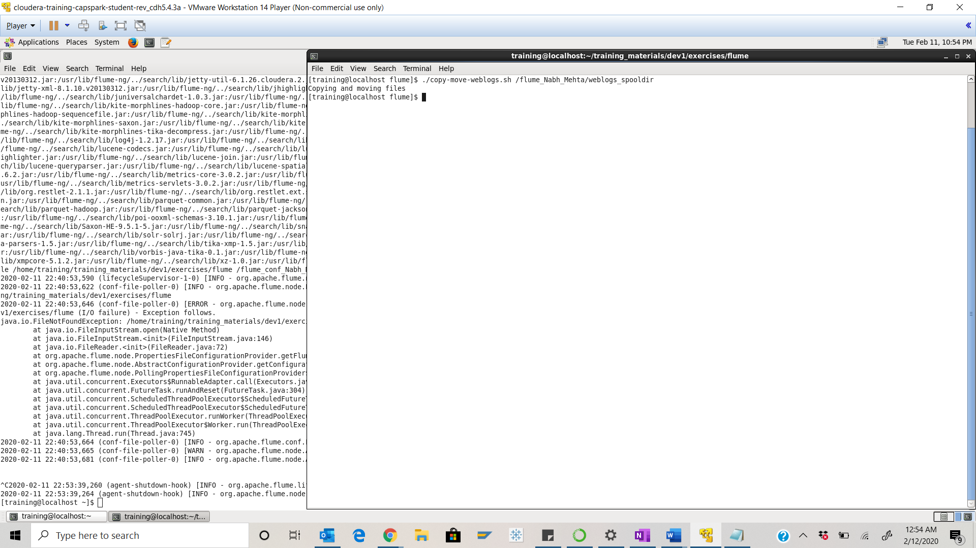

Step-10: Once the Flume agent has finished ingesting files, enter the following command in the terminal to terminate Flume:



Q. Using the file browser in HUE, go to the sink location

(/loudacre_FirstName_LastName/weblogs) and take a screenshot of the log files in the weblogs directory and paste it below.

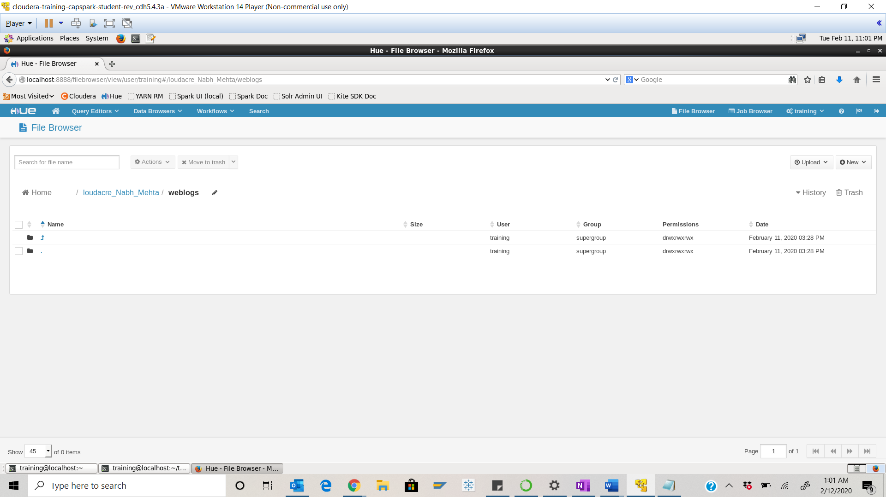

Part-5: Checksum: In this section we will perform a checksum

Step-11: Download the Checksum.zip file from eLearning in to the downloads folder **IN** the Cloudera VM using Mozilla Firefox.

Step-12: Execute the following command:



Q. Now type the command and execute. Take a screenshot of the shell output, highlight the zip file and paste it below.

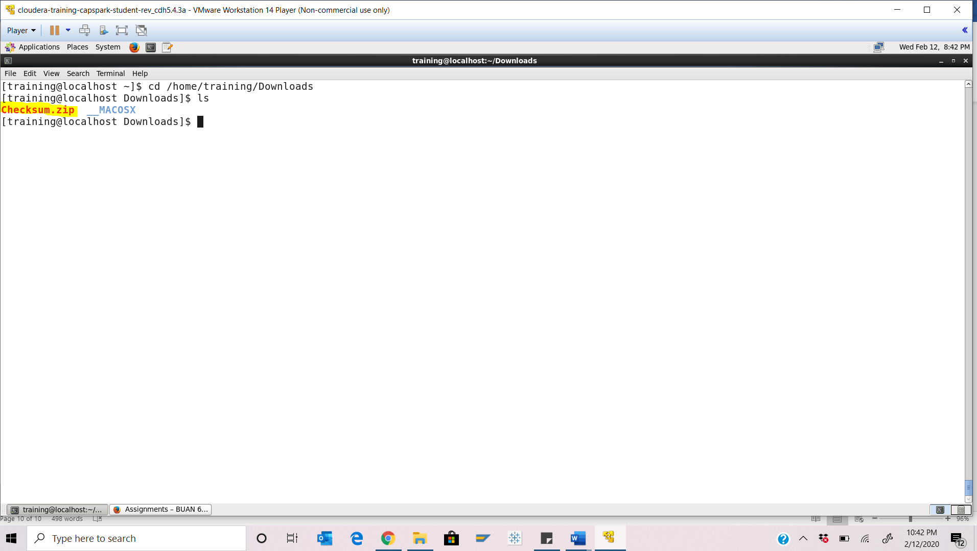

Step-13: Execute the following command at the shell prompt:



Q. Now type the command and execute. Take a screenshot of the shell output, highlight the contents of the zip file and paste it below.

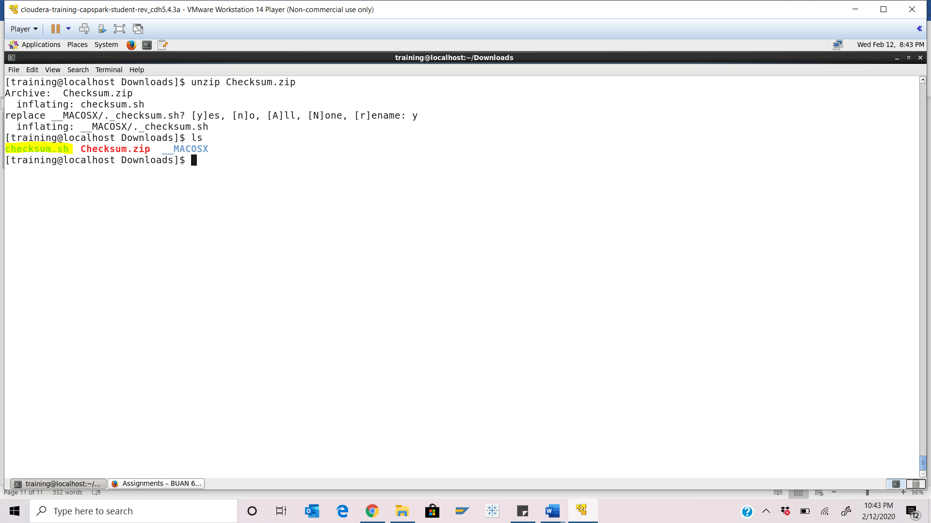

Step-14: Execute the following command at the shell prompt:

Then execute the following command:

Q. Take a screenshot of the shell output and paste it below.

Checksum Value - ab68e33c6598acd1a66fe981706c2e75

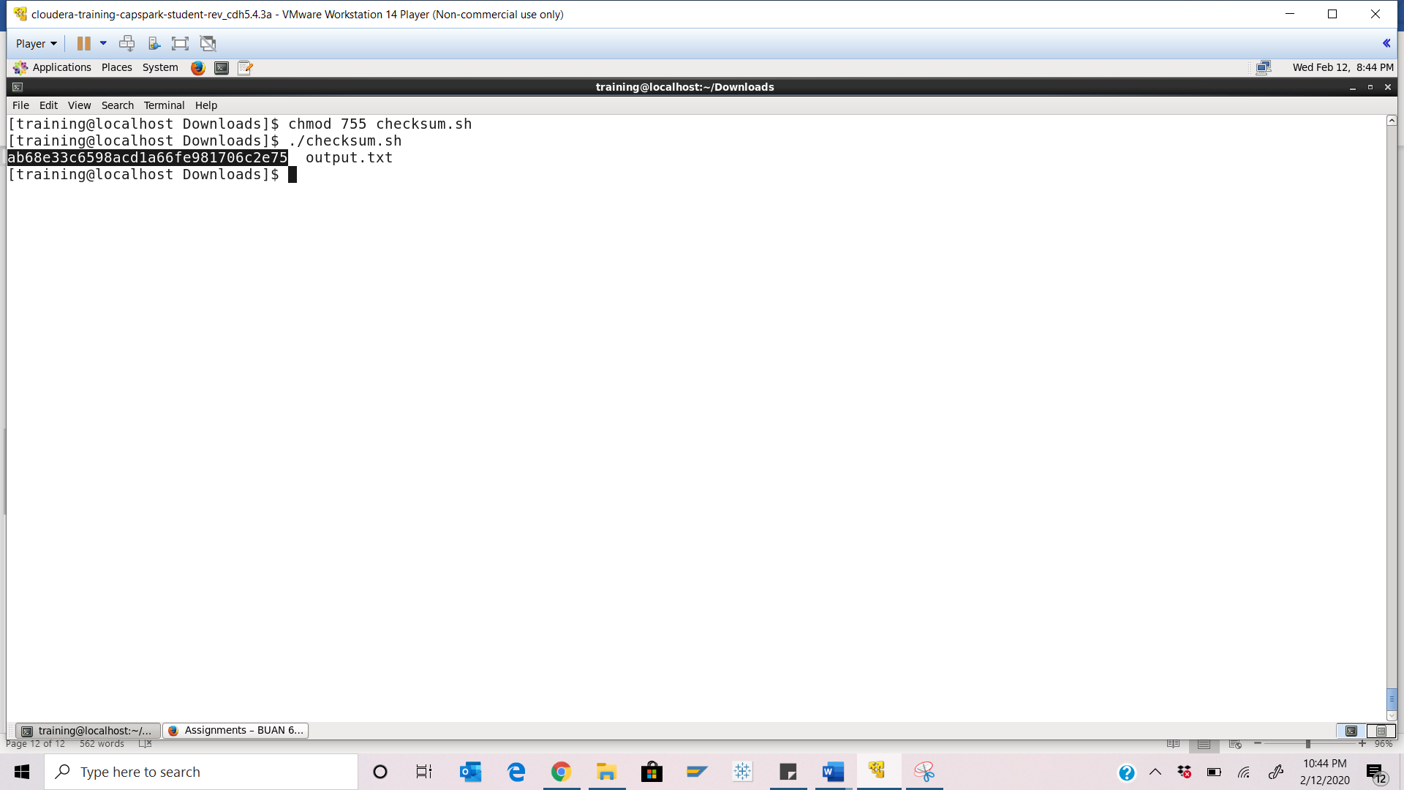

Step-15: Execute the following command at the shell prompt:

rm Checksum.zip checksum.sh output.txt



Q. Now type the command and execute. Take a screenshot of the shell output and paste it below.

